TAMIL NADU CO-OPERATIVE MILK PRODUCERS’ FEDERATION LIMITED (AAVIN)
AVADI DAIRY PLANT, CHENNAI
SUBMITTED BY: [Mohamad Rizvan H] [RA2512053010015]
DEPARTMENT OF [EIE- Automation & Robotics ]
DATE OF VISIT: 27-3-2026
ACADEMIC YEAR 2025 – 2026

1. Introduction and Background
The Tamil Nadu Co-operative Milk Producers' Federation Limited, popularly known as Aavin, stands as the backbone of the dairy industry in Tamil Nadu. The Avadi dairy unit is a critical hub within this network, primarily serving the northern outskirts of Chennai and the Tiruvallur district. Established to ensure a fair price for milk producers while providing high-quality dairy to consumers, Aavin operates on a three-tier cooperative model. This system starts from the Village Level Milk Producers Co-operative Societies, moving through District Level Unions, and finally reaching the State Level Federation. During the visit to the Avadi plant, it was evident that the facility acts as a high-tech bridge between rural farmers and urban markets, employing advanced engineering to process thousands of liters of milk daily while maintaining the nutritional integrity and safety of the product.

2. Milk Procurement and Reception
The process begins at the Raw Milk Reception Dock (RMRD). Milk is transported from various collection centers and Bulk Milk Coolers (BMCs) in insulated stainless steel tankers to maintain a temperature below 4°C, preventing bacterial growth during transit. Upon arrival, the milk undergoes a series of stringent Organoleptic Tests where experts check for odor, appearance, and temperature. Simultaneously, lab technicians perform rapid chemical tests to determine the Fat and SNF (Solid-Not-Fat) content, as well as checks for adulterants like urea, starch, or detergents. Once cleared, the milk is unloaded using high-capacity centrifugal pumps, passed through a "Chiller" to further drop its temperature, and stored in massive vertical silos with capacities reaching up to 1,00,000 liters. These silos are equipped with agitators to prevent fat separation and are heavily insulated to keep the milk chilled until it is ready for the pasteurization line.

3. The Pasteurization Process
Pasteurization is the heart of the dairy’s operations, utilizing the High-Temperature Short-Time (HTST) method. The milk is pumped through a Plate Heat Exchanger (PHE), where it is heated to exactly 72.4°C and held for 15 seconds. This specific combination of temperature and time is scientifically calibrated to destroy pathogenic bacteria without compromising the milk's flavor or vitamins. The system at the Avadi plant is highly automated; if the milk fails to reach the required temperature, a Flow Diversion Valve (FDV) automatically redirects the milk back to the balance tank for reprocessing. Following the holding period, the milk is rapidly cooled back down to 4°C. This thermal shock is vital for extending the shelf life of the milk. The entire process is monitored via a centralized control room using SCADA (Supervisory Control and Data Acquisition) systems, ensuring that human error is minimized and food safety is guaranteed.
4. Homogenization and Standardization
To ensure that every pouch of Aavin milk has a consistent texture and taste, the milk undergoes Homogenization. In its raw state, milk contains fat globules of varying sizes that tend to float to the top and form a cream layer. The homogenizer forces the milk through a microscopic valve at extremely high pressure (approx. 2000–2500 psi). This mechanical process breaks the fat globules down to less than 2 microns in size, distributing them evenly throughout the liquid. This ensures that the milk remains "uniform" and does not separate in the pouch. Additionally, the plant performs Standardization, where the fat and SNF levels are adjusted to meet specific product categories. For instance, "Toned Milk" (Blue packet) is standardized to 3.0% Fat and 8.5% SNF, while "Full Cream Milk" (Orange packet) is adjusted to 6.0% Fat and 9.0% SNF, allowing Aavin to cater to different dietary needs.

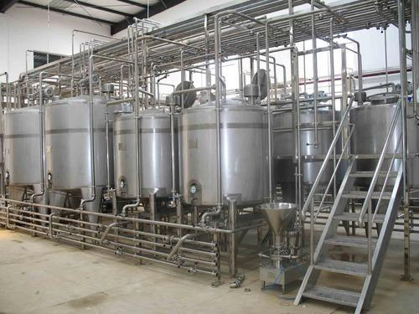
5. Automated Milk Packing System (Detailed Analysis)
The most technologically impressive section of the Avadi plant is the Automated Milk Packing System. This section utilizes Vertical Form Fill Seal (VFFS) machines, which operate with minimal human intervention to ensure maximum hygiene. The process begins with a large roll of food-grade LDPE (Low-Density Polyethylene) film. As the film unrolls, it passes through a UV-sterilization chamber to kill any surface bacteria before it ever touches the milk. The machine then folds the film into a cylindrical shape around a "forming tube." A vertical sealer heat-seals the edges of the film to create a continuous tube.
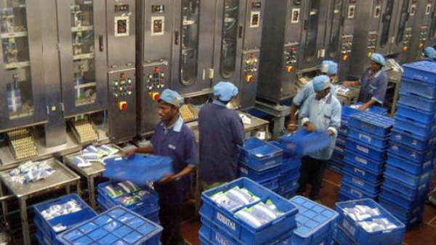
The automation is precise: as the tube moves downward, a horizontal sealer creates the bottom seal of a pouch. Simultaneously, a measured volume of chilled milk is injected into the pouch through the filling pipe. The machine then creates a top seal, which also acts as the bottom seal for the next pouch, and a high-speed blade cuts the pouches apart. The Avadi plant uses multi-track machines capable of packing thousands of pouches per hour. Every aspect—from the volume of milk to the temperature of the sealing jaws—is controlled by a PLC (Programmable Logic Controller). This automation ensures that there is zero leakage, the weight is accurate to the milliliter, and the milk remains untouched by human hands, significantly reducing
the risk of contamination.
]
6. Cleaning-In-Place (CIP) Systems
Hygiene at the Aavin Avadi plant is maintained through an advanced Cleaning-In-Place (CIP) system. Instead of dismantling the massive network of pipes, tanks, and pasteurizers, the CIP system circulates cleaning solutions throughout the entire circuit. The cycle typically involves a pre-rinse with water, followed by a caustic wash (Sodium Hydroxide) to dissolve fats and proteins, a second rinse, an acid wash (Nitric Acid) to remove mineral scales, and a final rinse with sterilized water. This entire sequence is automated, with sensors measuring the concentration of chemicals and the temperature of the water to ensure the equipment is surgically clean. This rigorous sanitation protocol is performed daily, ensuring that the plant meets international food safety standards (ISO and HACCP).
7. Storage and Cold Chain Management
Once the pouches are packed and crated, they are immediately moved into Cold Storage Rooms (Walk-in Coolers) maintained at a temperature of 1°C to 5°C. This is a critical stage in the "Cold Chain." Milk is a highly perishable commodity, and even a slight rise in temperature can trigger bacterial spoilage. The Avadi plant features large-scale refrigerated storage areas where crates are stacked systematically according to their variants (Blue, Green, Orange, etc.). From these cold rooms, the milk is loaded into insulated distribution vans in the early hours of the morning. The logistics are timed perfectly so that the milk processed in the evening reaches the consumer’s doorstep by dawn, ensuring that the product is as fresh as possible.
8. Quality Control and Lab Analysis
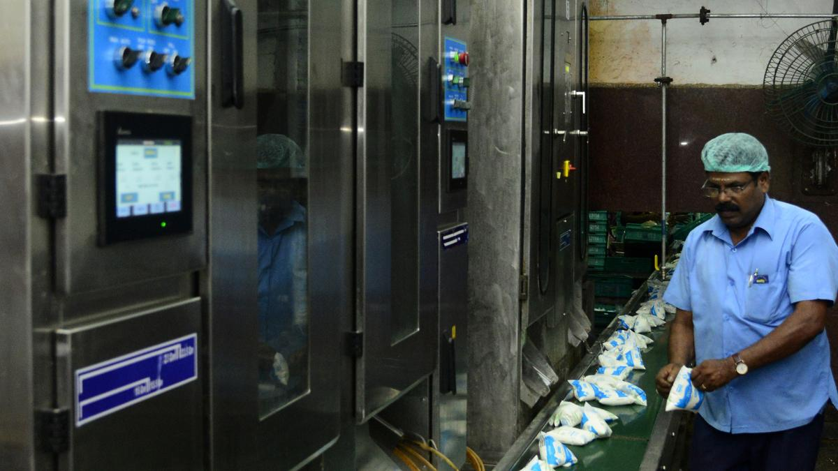

Aavin’s commitment to quality is evident in its multi-stage laboratory testing. Beyond the initial reception tests, "In-Process" samples are taken from the pasteurizer and the packing machines every hour. These samples are tested for MBRT (Methylene Blue Reduction Test) to check bacterial load and for the efficiency of pasteurization (Phosphatase test). The lab also performs sensory evaluations to ensure the color, flavor, and thickness of the milk meet Aavin’s brand standards. Any batch that does not meet the strict criteria is rejected before it can leave the facility. This rigorous oversight is what has built the trust Aavin enjoys among millions of households in Tamil Nadu.built the trust Aavin enjoys among millions of households Nadu.

9. Utilities and Support Infrastructure
The dairy plant's operation is supported by several heavy-duty utility sections. The Refrigeration Plant uses ammonia compressors to
provide the chilled water necessary for the PHEs and cold storage. The Boiler Section generates the high-pressure steam required for pasteurization and CIP. Additionally, an Effluent Treatment Plant (ETP) is located on-site to process the wash-water. Since dairy waste is high in organic matter, the ETP uses biological treatments to ensure that the water released from the factory is environmentally safe and complies with Pollution Control Board norms. This reflects Aavin’s commitment to sustainable and responsible manufacturing.

10. Conclusion and Personal Learning
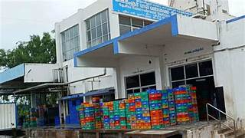
The industrial visit to the Aavin milk factory in Avadi provided a profound understanding of how large-scale food processing operates. It was fascinating to see how a simple raw material like milk is transformed through a series of complex engineering steps into a standardized, safe, and packaged product. The highlight of the visit was undoubtedly the automated packing system, which showcased the perfect integration of mechanical engineering and food technology. Observing the SCADA-controlled pasteurization units and the high-speed VFFS machines reinforced the importance of automation in maintaining consistency and safety in the food industry. This visit served as a bridge between theoretical classroom concepts and real-world industrial application, highlighting the vital role Aavin plays in the state's economy and public health.

